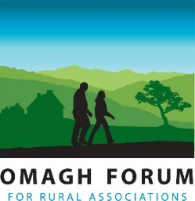
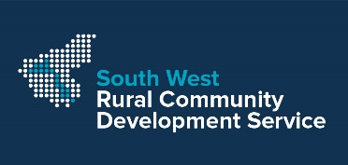
Omagh Forum for Rural Associations

Warm, Well and Connected - Community Needs
The Department for Communities and the Department for Agriculture, Environment and Rural Affairs are reaching out to communities via Omagh Forum and SWRCDS to help people that have been acutely affected by COVID 19. We want your group to reach out locally and are asking for you to identify what is needed. We are here to assist with planning and will consider funding activities you need that help the target audience below. The project budget has to be shared widely in all communities and we ask you to plan prudently. Your key role will be to identify need/s, suggest project ideas, get people to take part and to get their feedback afterwards.

Name of
Organisation /Group:
Address  (inc. postcode): |  | Email:
Main Contact: |  | Tel Number:

(Please tick any that your project addresses - at least one theme and one target audience)
Themes  [ ] Physical activity  [ ] Mental health  [ ] Nutrition  [ ] Isolation | Target Audience  [ ] Children & Young people  [ ] Older people, particularly those living alone  [ ] People living with Disability and their Carers  [ ] Any group who has lost income as a direct result of the pandemic (particularly women & young people aged between 18-24, who have been disproportionately affected)  [ ] Clinically extremely vulnerable (previously shielding)  [ ] People from Ethnic Minorities

Section 2
WHAT? | WHEN? | HOW?
Briefly say what you want to do and how you will do it?  ….. | When will this be done, must be before 31st March 2021 | How many people will  benefit?
resources | costs | Notes
eg. Craft Materials | £5 per set  Total Costs | Any additional notes

Signature ___________________________________________ (can be typed)

Position ___________________________________________ Date________________

Please return this form by email: laurence@omaghforum.org

By post to: Omagh Forum, Community House, 2 Drumragh Avenue, OMAGH, BT78 1DP

If you have any queries about this form please contact: 028 82 251559

