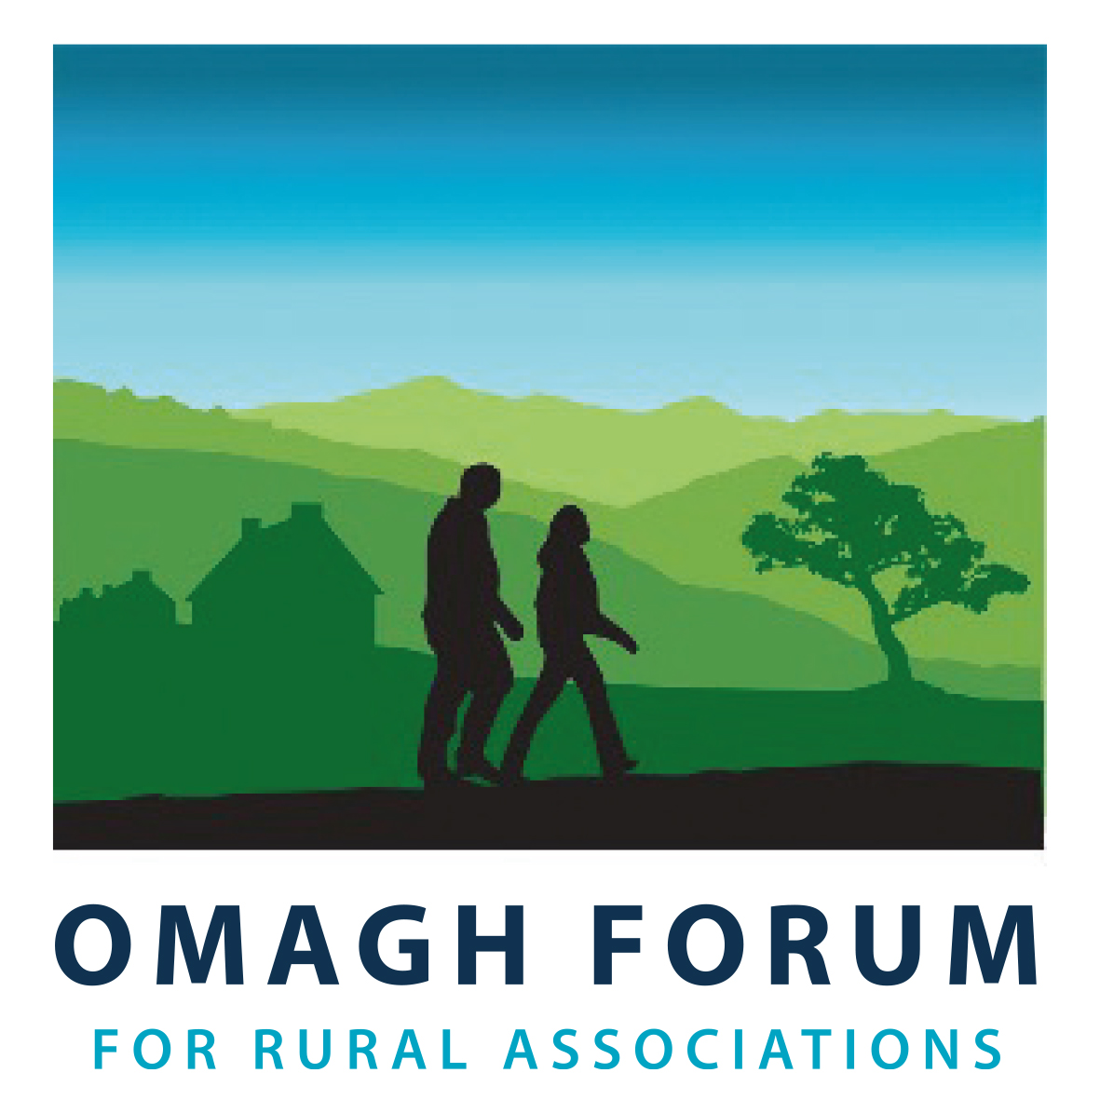

Rural Micro Capital Grant Scheme 2022

Guidance Notes for Applicants

Overview

This Scheme is funded under the Department of Agriculture, Environment and Rural Affairs Tackling Rural Poverty and Social Isolation Programme. The key aim of this Programme is to assist in tackling poverty and social isolation within rural communities across Northern Ireland, and, in line with the draft Green Growth Strategy for Northern Ireland provide opportunities to implement environmental improvements / energy efficiency measures. More information on the Tackling Rural Poverty and Social Isolation Framework is provided at Annex 3.

For the Fermanagh & Omagh District Council area, Omagh Forum for Rural Associations is delivering this Scheme on behalf of the Department of Agriculture, Environment and Rural Affairs.

Key objectives

The Rural Micro Capital Grant Scheme 2022 has been designed to:

- Help rural community-led, voluntary groups to address local issues of access poverty, financial poverty and social isolation;
- Improve the lives of rural communities, and in particular the wellbeing of isolated individuals; and,
- In line with the draft Green Growth Strategy for Northern Ireland provide opportunity to community-led, voluntary groups to implement energy efficiency measures / environmental improvements.

Omagh Forum for Rural Associations
Omagh Community House
2 Drumragh Avenue,
Omagh.
BT78 1DP
028 8225 1559
grants@omaghforum.org

The Grant Scheme

Micro Capital grants between £200 and £1,500 are available to rural community-led, voluntary organisations for projects tackling issues of local poverty and / or social isolation, and / or implementing energy efficiency measures / environmental improvements. Projects must focus on one of the following four themes:

- Modernisation (of building(s) / assets)
- Information Communication Technology (ICT)
- Health and Wellbeing
- Energy Efficiency / Environmental Improvement. NB: Please note environmental improvements should be part of an overall project and not the sole project and should not represent more than 15% of the total project cost.

The Rural Micro Capital Grant Scheme can offer grant aid from 50% up to 85% of the total eligible cost of your project. NB: The total project cost must not exceed £3,000. Match funding for your contribution of at least 15% must be in the form of a ‘cash’ contribution. Labour or ‘in-kind’ contributions will not be accepted.

In order to ensure that as many groups as possible get the opportunity to benefit from this Scheme, organisations can only make one application to the Scheme.

What can be funded?
Grant aid can only be used to meet costs associated with capital equipment, the improvement of a capital asset and / or the extension of the useable life of a capital asset. Groups can apply for a wide range of capital items, such as office equipment, furniture, sports goods, kitchen fittings and minor capital works to improve premises. NB: Please note that clothing and consumables e.g. ink, paper, etc. are ineligible

Eligible items must clearly relate to the key themes of (i) Modernisation*, (ii) ICT, (iii) Health & Wellbeing, or (iv) Implement energy efficiency / environmental improvements measures.

In recognizing the impact of Covid 19, and the need for investment to reopen and safely operate venues, eligible costs may include structural alterations, e.g. ventilation systems for rooms without windows; heating rooms previously unused rooms to provide more space; removing walls to improve space and improve distancing. Furthermore, goods which have a degree of permanence (anticipated to have a life beyond 1 year) or can be permanently affixed to the venue can also be considered eligible. This would allow items including sanitiser stations, perspex screens, signage, floor markings, refillable spray bottles, automatic doors, replacement furniture that can be wiped down and contactless thermometers.

To encourage local communities to implement energy efficiency / environmental improvements measures, eligible costs may include, e.g., draft proofing, double glazed windows, change of lighting to LED, light sensors/timers, insulation, replace kettles with a water boiler, raised beds and tree planting. NB: Please note environmental improvements should be part of an overall project and not the sole project and should not represent more than 15% of the total project cost.

As this is a capital programme, the following types of activity cannot be funded.

Examples of Ineligible Activities
Training | Running costs & Consumables (e.g. ink cartridges, paper) sanitizer, paint
Hospitality, Food, Drink | Staff / Volunteer expenses
Clothing, Uniforms, including PPE (gowns, masks, gloves, etc.) | Labour costs not directly associated with purchased Capital works / items
Motorised vehicles | Feasibility Studies / Reports

This list is not exhaustive, if you are in doubt about the eligibility of your project please contact Omagh Forum for Rural Associations before applying.

*Your organisation must ensure that all actions undertaken in relation to this project comply with the relevant statutory requirements and legislation in existence during the lifetime of the project. Projects involving work to modernise a building will only be accepted from either the owner or leasee. Only one application can be accepted per building.

Who can apply?
You can apply for a Micro Capital grant if:
- you are a not-for-profit community / voluntary organisation;
- the organisation is based in a rural area. A definition of rural is detailed at Annex 1;
- you have a formal Constitution or governing documents;
- you have a minimum of three people on your management committee (this must be clearly detailed within your constitution or governing documents);
- you have a bank or building society account in the name of your group, which requires at least two signatures for each withdrawal (this must be clearly detailed within your constitution or governing documents);
- you can enclose copy of your most recent Accounts or a signed Financial Statement. The Financial Statement must be signed by a person in authority within your organisation, i.e. Chairperson, Secretary or Treasurer, or provided with the authority to act on the organisation’s behalf; If the latter is the case, evidence of permission must be uploaded to the online system.
- you need a capital grant between £200 and £1,500 for a specific poverty or social isolation project
- You are the sole applicant and owner OR leasee of the building for which the application to RMCGS 2022 is being made.
- you can provide two quotes (net after taking into account recoverable VAT) for each item to be purchased. Delivery costs can be included as an additional cost. NB: Online quotes (e.g., Amazon) cannot be from the same supplier.
- your organisation can deliver the project, pay the supplier(s) and submit a grant claim by 31 March 2023 (including reimbursement of credit cards / loans);
- you are appropriately insured or prepared to obtain appropriate insurance if awarded a grant (building or contents insurance as appropriate).

What cannot be funded?
We cannot fund the following:
- Organisations based in urban areas;
- Individuals, Sole traders and / or Commercial trading companies;
- Companies that exist to distribute a profit;
- Statutory Authorities or organisations governed by Statutory Authorities;
- Appeals or charities set up to support statutory bodies;
- Organisations with an income in excess of £80,000 (not including in-year restricted funds, e.g. non-business / grant income);
- More than one application to modernise a building.

- Costs already incurred – an application cannot be made for capital items that have already been ordered or received before the award of a Letter of Offer;
- Grant cannot be used to match another funder’s project;
- Projects where the value of match funding is greater than the value of grant; and
- Second-hand equipment.

Eligibility
Your application will be considered against the Eligibility Criteria for the Scheme (Please carefully consider the criteria listed at Annex 2, this will be used to determine if your application is eligible). Only the information contained within your application will be used during this process and no additional information other than that provided with your application will be considered.

As this Scheme is funded as part of DAERA’s Tackling Rural Poverty and Social Isolation Programme, you must also demonstrate within your application how your project will contribute to reducing rural poverty and / or social isolation within your local community. Annex 3 refers.
Please note
- We intend to inform applicants if their application is considered ‘ineligible’ within six weeks of the closing date.

- If your application is eligible, we will contact you with details of the Letter of Offer Workshops* in your region. You must not start your project until you have attended the Letter of Offer Workshop and/or contacted your local RSN to agree to the terms and conditions of the Letter of Offer.

*If your organisation’s chosen representative previously attended a Letter of Offer Workshop, it is not compulsory for that individual to attend the Workshop for 2022. However, if that individual is no longer the group’s chosen representative, then a new representative will need to attend.

- Your project must be completed and your claim for grant submitted by 31 March 2023. No extensions will be given.

- You must incur the initial cost of your purchases and then claim your grant once your project is completed. Your organisation must have paid for all project expenditure and submitted a claim for payment by 12 noon on 31 March 2023. No advance payments will be provided.

- DAERA need to be made aware immediately of any Conflict of Interest, however arising, that may occur between your organisation and any other organisation, supplier, person or employee associated in any way with the delivery of the Project.
- Following completion, your project may be selected by DAERA for a verification check to ensure your grant aid is being used for the purposes intended.

- The application should identify the likely benefits to the rural population of the completed project by recording the expected number of people with access to or using the new or improved facilities/equipment.

How to apply

This Scheme is open for applications from Monday 05 September 2022 until 12 noon on Friday 30 September 2022.

To apply, complete the online form by entering all the relevant information and uploading all the additional documents required. The application should be submitted by a committee member of the organisation. Upon submission of the online application form, an auto generated e-mail receipt confirming the application has been submitted will issue to the email used to register the application.

If you have any queries please contact Omagh Forum For Rural Association grants@omaghforum.org

The following documents must be included with your application:

- Your group’s Constitution / governing documents. These documents should clearly detail that there are more than 2 members on the Management Committee and state the group’s financial procedures for transactions, noting that at least 2 signatures are required.

- Your most recent Accounts or a signed Financial Statement, signed by a committee member of the organisation.

- Two like-for-like, quotations from at least 2 different suppliers for item(s) that you wish to purchase. Procurement requirements are outlined at Annex 1 of these guidance notes. NB: Online quotes (e.g., Amazon) cannot be from the same supplier.

- The lease or proof of ownership (for a project involving work to your building)
Please refer to Annex 1 and 2 for further information.
The onus to ensure that your application is received before the closing date rests solely with each applicant. Therefore please ensure that you leave sufficient time to submit your application by the closing date.

UNDER NO CIRCUMSTANCES WILL LATE OR INCOMPLETE APPLICATIONS BE ACCEPTED.

If you would like more information about the Rural Micro Capital Grant Scheme 2022 or have a specific query, please contact:
Omagh Forum for Rural Associations
Omagh Community House
2 Drumragh Avenue,
Omagh.
BT78 1DP
028 8225 1559
grants@omaghforum.org

The Department takes data protection, freedom of information and environmental information issues seriously. It takes care to ensure that any personal information received from you is dealt with in a way which complies with the requirements of the General Data Protection Regulation (2016). This means that any personal information you supply will be processed principally for the purpose for which it has been provided. However, the Department is under a duty to protect the public funds it administers, and to this end may use the information you have provided for this purpose.

A full copy of the DAERA Privacy Statement can be found here:- https://www.daera-ni.gov.uk/daera-privacy-statement

The Rural Micro Capital Grant Scheme is funded by the
Department of Agriculture, Environment and Rural Affairs as part of its
Tackling Rural Poverty and Social Isolation Programme.

Annex 1
Rural Location

Definition of a Rural Area

SETTLEMENTS WITH POPULATIONS IN EXCESS OF 5,000 INHABITANTS.
For the purposes of the Scheme, rural is defined as all those areas outside the statutory development limits of those towns with a population in excess of 5,000 inhabitants.
Settlements with populations in excess of 5,000 inhabitants are listed below based on the Review of the Statistical Classification and Delineation of Settlements March 2015 produced by NISRA.
The structure of the new classification of settlements is shown in Table 1. The table lists the settlements in each band, in order of their 2011 Census Day population estimates.
Table 1
Classification | Settlement Development Limit (SDL)
BAND A - BELFAST | BELFAST CITY
BAND B - DERRY CITY | DERRY CITY
BAND C - LARGE TOWN (POPULATION 18,000+) | METROPOLITAN NEWTOWNABBEY
CRAIGAVON URBAN AREA including
AGHACOMMON
 | BANGOR
 | METROPOLITAN CASTLEREAGH
 | LISBURN CITY
 | METROPOLITAN LISBURN
 | BALLYMENA
 | NEWTOWNARDS
 | CARRICKFERGUS
 | NEWRY
 | COLERAINE
 | ANTRIM
 | OMAGH TOWN
 | LARNE
Band C Total | 14
BAND D - MEDIUM TOWN  (POPULATION 10,000 - 17,999) | BANBRIDGE
 | ARMAGH
 | DUNGANNON
 | ENNISKILLEN
 | STRABANE
 | LIMAVADY
 | COOKSTOWN
 | HOLYWOOD
 | DOWNPATRICK
 | BALLYMONEY
Band D Total | 10
BAND E - SMALL TOWN  (POPULATION 5,000 - 9,999) | BALLYCLARE
 | COMBER
 | MAGHERAFELT
 | WARRENPOINT / BURREN
 | PORTSTEWART
 | NEWCASTLE
 | CARRYDUFF
 | DONAGHADEE
 | KILKEEL
 | PORTRUSH
 | DROMORE_BANBRIDGE
 | BALLYNAHINCH
 | COALISLAND
 | GREENISLAND
 | BALLYCASTLE
 | CRUMLIN
 | RANDALSTOWN
Band E Total | 17

Footnotes:
- The names and the listings of the settlements have been taken from the set of Settlement Development Limits (SDLs).

- The labelling of bands in this classification as ‘towns’ or ‘villages’ is purely descriptive. It is noted that, for example, some settlements described in the classification as ‘towns’ are legally ‘cities’.

If you are in any doubt about whether your group is located in a rural area, please contact Omagh Forum for Rural Associations before submitting your application.

Procurement

Estimated values | Action & Minimum Number | Comments
Up to £3,000  (maximum total project cost under RMCGS 2022) | At least 2 price-checks / quotations from different suppliers  NB: Online quotes (e.g., Amazon) cannot be from the same supplier. | - Quotes should be ‘like-for-like’; like for like refers to the specification of the item(s). E.g. TV detail would include like for like screen size).  - Quotes can include delivery costs as an additional cost.  - The lowest quotation should be selected with corresponding costs detailed on the application form. DAERA will reimburse at the cost of the lowest quotation

Annex 2

NB: This document details the criteria that will be used to confirm if your application is eligible. The application must be submitted by a committee member within the organisation.

 | ELIGIBILITY CRITERIA | Yes (√ )  No (X) | COMMENT
1. | Applicant is based in a rural area. (Q1.1)
2. | Applicant organisation is not-for-profit community / voluntary. (Q1.9)
3. | The project addresses an issue of local poverty and / or social isolation, in line with the key objectives of the Rural Micro Capital Grant Scheme 2022 or will implement energy efficiency / environmental improvements? (Q 2.3)
4. | The project has not commenced. (Q2.6)
5. | At least two quotes have been provided for each item to be purchased. (Q3.1 & Annex A)
6. | Grant requested is between £200 and £1,500 (Q3.2)
7. | Applicant is providing minimum 15% match funding (Q3.2)
8. | The project can be completed and grant claimed by 31 March 2023? (Q3.3)
9. | Applicant has provided their Constitution / Governing documents which confirms the Management Committee has a minimum of three people and at least two signatories are required for cheques / withdrawals.
10. | Applicant has provided their most recent Accounts or signed financial statement.
11. | For projects involving work to modernise a building, proof of ownership or a lease have been provided.
12. | Applicant has an annual income less than £80,000 (not including in-year restricted funds, e.g. non-business / grant income)

** APPLICANT MUST MEET ALL ELIGIBILITY CRITERIA TO PROCEED TO SELECTION **
Please remember – you must supply the relevant documentation with your application, e.g. Constitution / Governing documents, quotes, copy of your lease / proof of ownership for projects involving work to your building.

Failure to supply these documents will result in your application being deemed ineligible.

Closing Date for receipt of completed application forms is:

12 noon on Friday 30 September 2022

No LATE or INCOMPLETE applications will be accepted.

Annex 3

Tackling Rural Poverty and Social Isolation Framework –
Draft Green Growth Strategy for Northern Ireland
The Tackling Rural Poverty and Social Isolation Framework focuses on three Priority Areas for Intervention, namely Access Poverty, Financial Poverty and Social Isolation, and aims to support measures designed to address these priorities in rural areas. It is recognised that there is potential for significant overlap between the three priority areas and that individual measures may address more than one priority area.
- Access Poverty - this priority aims to improve access to key services for vulnerable rural dwellers by supporting interventions which;
- Improve urban-rural linkages (e.g. through the provision of better transport and broadband services etc.);
- Improve access to key services (e.g. healthcare, education and training, leisure facilities, library services, advice services, childcare etc.).

- Financial Poverty – this priority aims to address financial poverty among vulnerable rural dwellers by supporting interventions which:
- reduce household expenditure or other living costs (e.g. transport costs);
- increase household incomes; (e.g. through improved employability, employment opportunities, entrepreneurship, increased benefit uptake etc.);
- address issues relating to the additional costs faced by people living in rural areas (e.g. fuel costs);
- address the barriers to escaping financial poverty (e.g. low qualifications, low skills, lack of access to affordable childcare, lack of access to quality jobs, disengagement, lack of access to information and advice, poor health etc.);
- help alleviate the effects of financial poverty (e.g. food poverty, health problems, obesity among children, debt etc.).

- Social Isolation – this priority aims to address social isolation among vulnerable rural dwellers by supporting interventions which:
- promote positive mental health and wellbeing;
- increase opportunities for social engagement (e.g. social activities, sport and leisure activities, cultural activities etc.);
- provide support to groups at risk of social isolation (e.g. farmers, older people, people with disabilities, disengaged youth, etc.).

Draft Green Growth Strategy for Northern Ireland
This draft Strategy establishes Government’s Green Growth vision and principles and sets out its commitments to tackling the climate crisis. Already, Northern Ireland has taken significant action for the climate and our environment, has placed nature and biodiversity on a path to recovery, and moved from a high to a low emissions society.
Green Growth means recognising and accepting the impact we have on our planet and doing something about it.
Green Growth is about more than just climate targets. It also considers the wider environment as well as green jobs. Northern Ireland’s environment is one of its most important assets. Clean air, good quality water and the green and blue spaces are part of our ‘natural capital’. The RMCGS 2022 has added the Theme to provide the opportunity to community-led groups to consider going green and become more sustainable.

