Contents
Registering For RMCGS 2022 1
First-Time registrations 3
Logging/signing back in once an applicant has applied 12
Users who already have an NI Direct or Government Gateway Accounts 14

Registering For RMCGS 2022

https://daera.outsystemsenterprise.com/RMCGS/StartPage
Always, always, always direct users to the above URL, nothing else.
It will open to the following screen
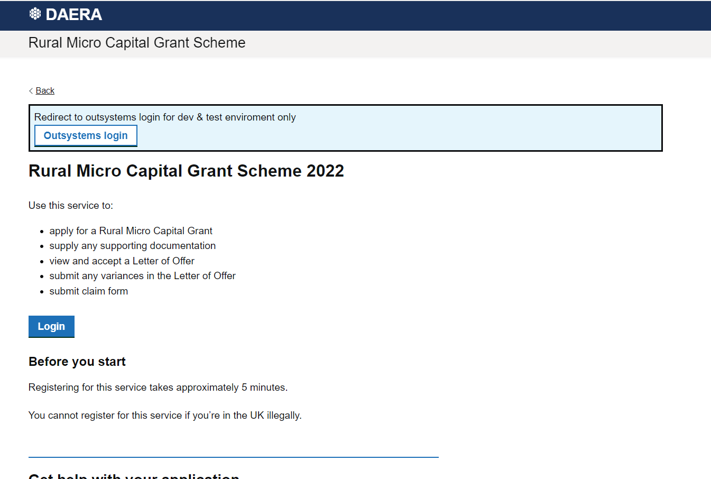

Once they click login on the above screen the following will appear. The users can choose NI Direct or Government gateway to Register with.
N.B. this is a first-time registration. Once they register they will then come here and log in.
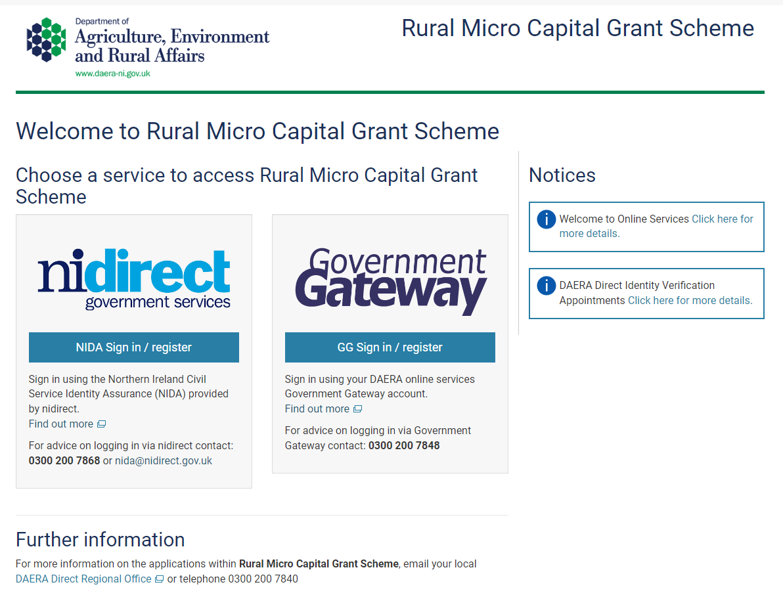

First-Time registrations
The login/register button selected above will direct them to the log in page. This document will only showcase the NI Direct route.
For the persons first-time they will need to select Create Account.
*For users who have a log in to either site already please see instructions at the end of this document
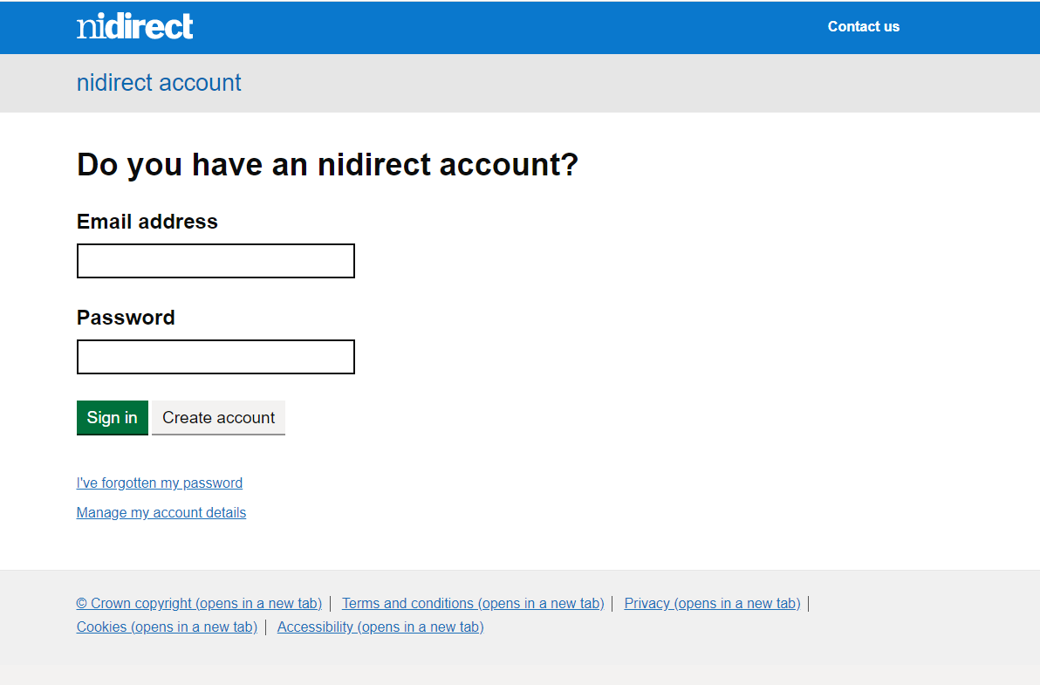

The following screens will need to be completed. The application is low level security so the users don’t need to prove their identity with passports etc, just the screens that follow.
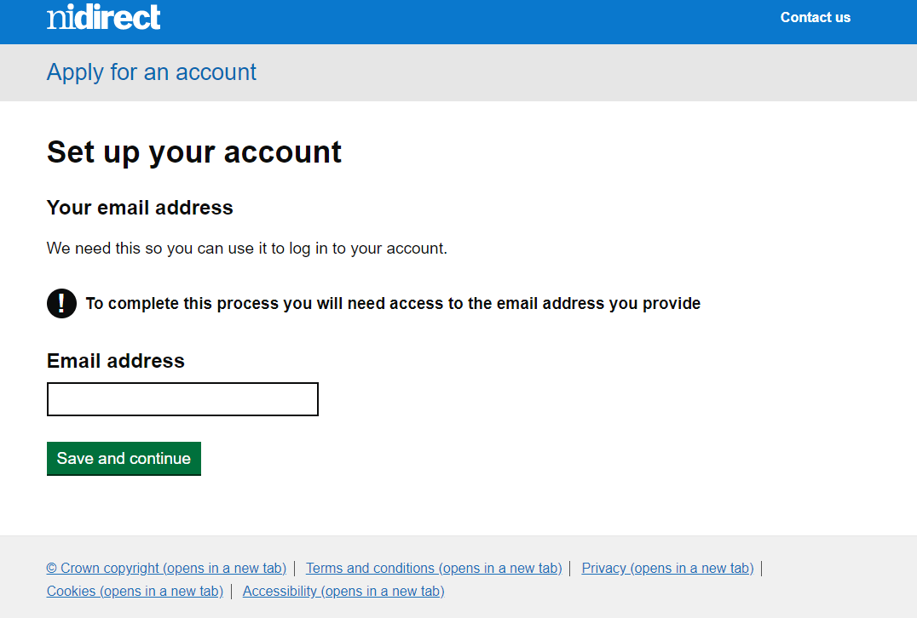
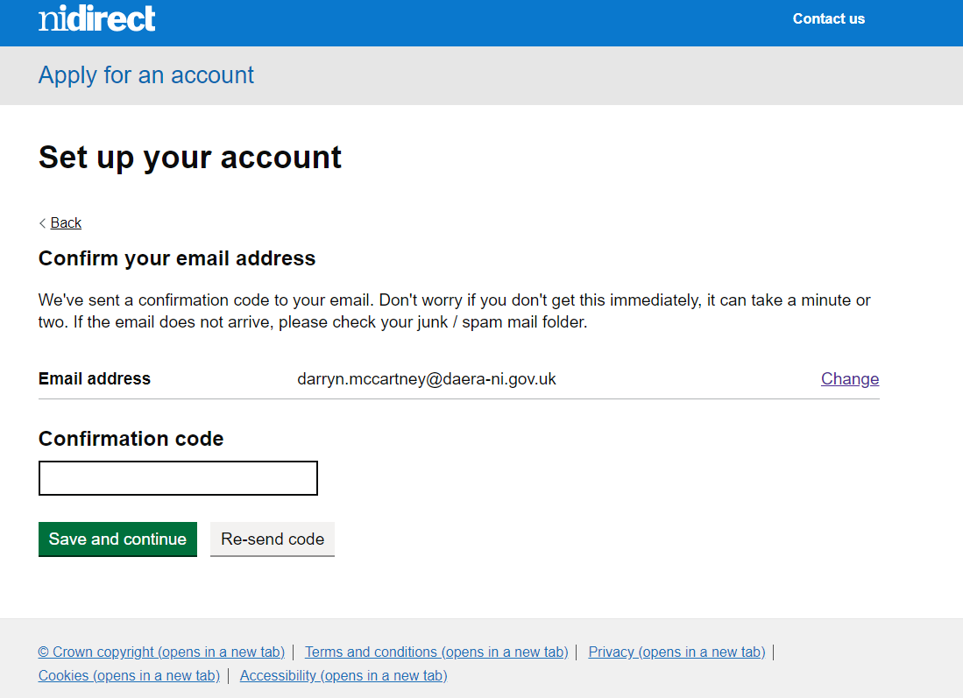
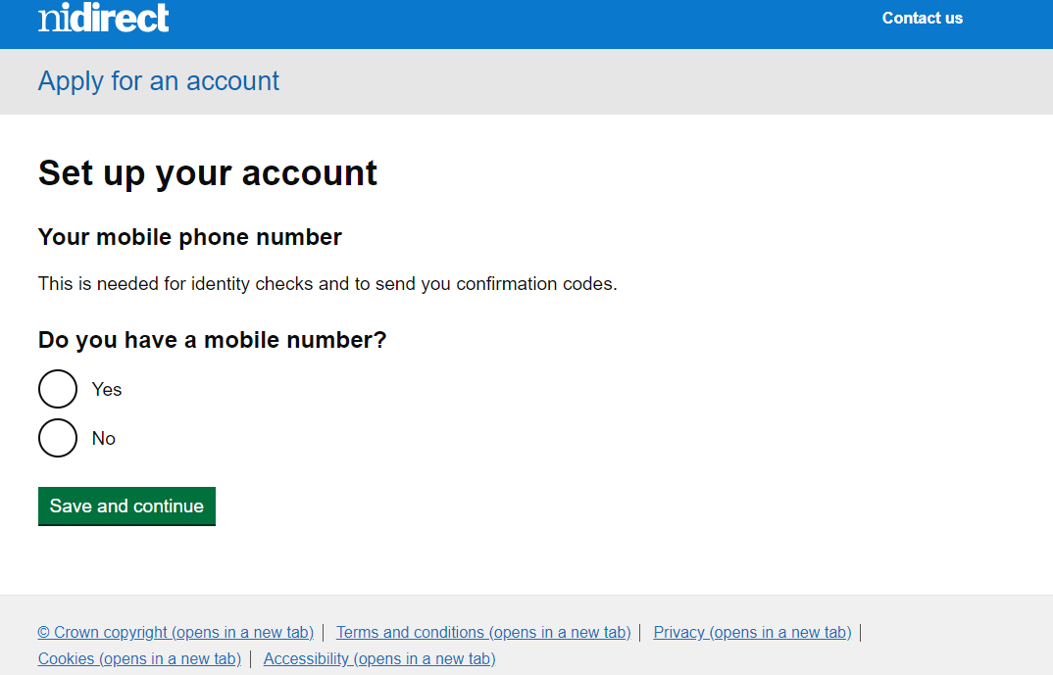
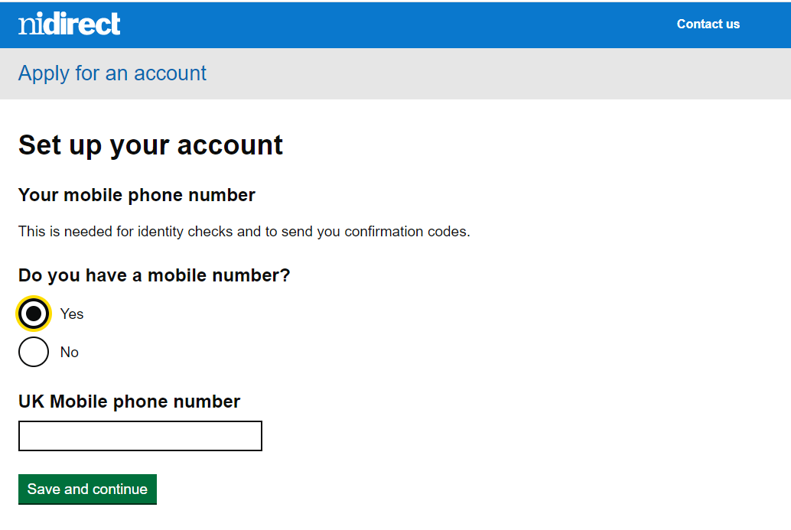
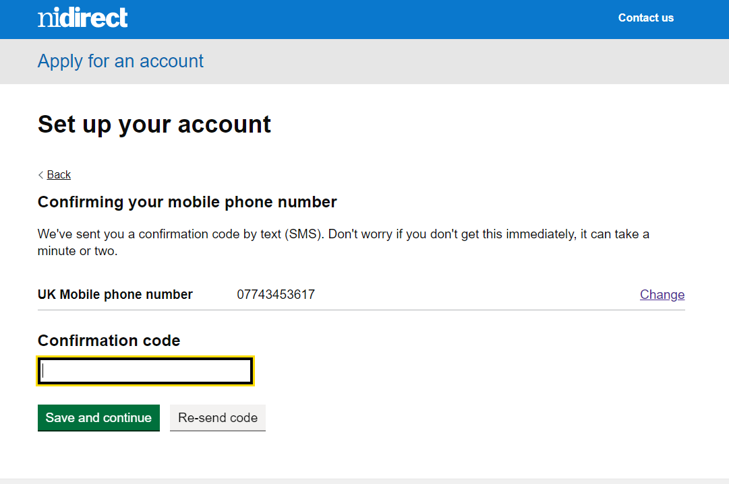
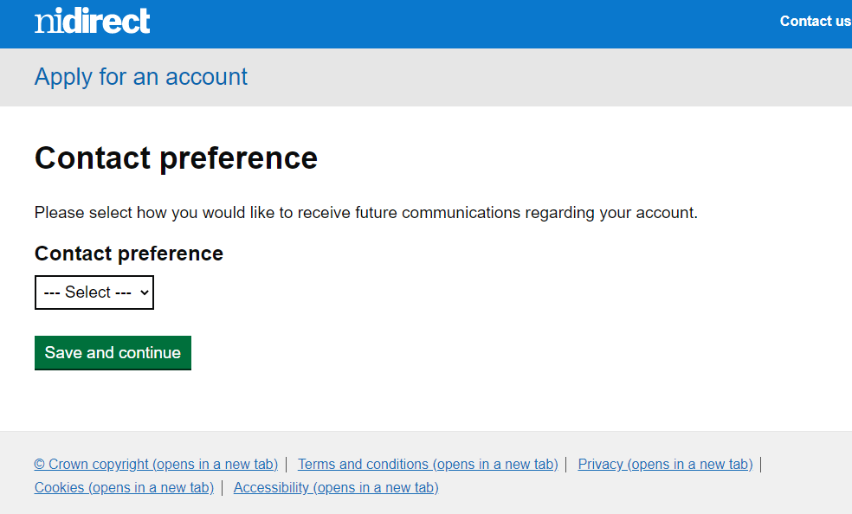
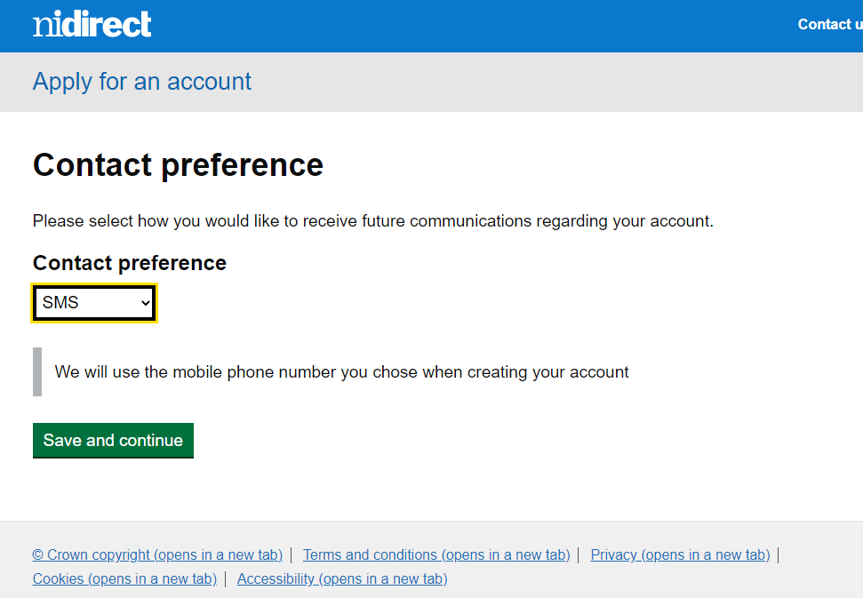
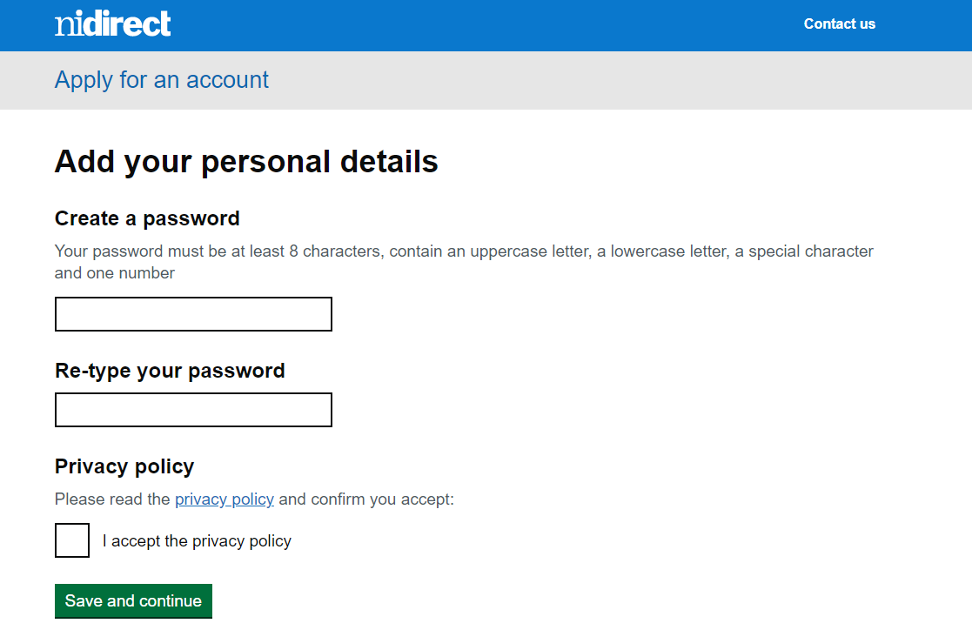
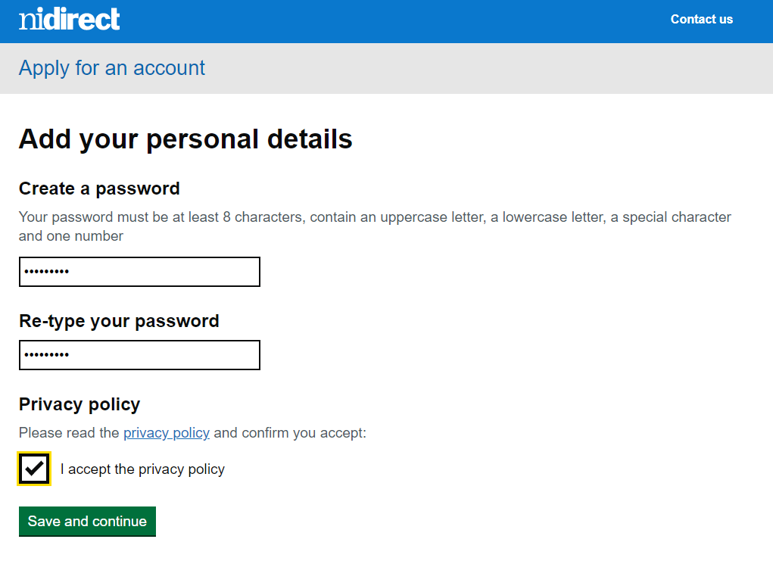
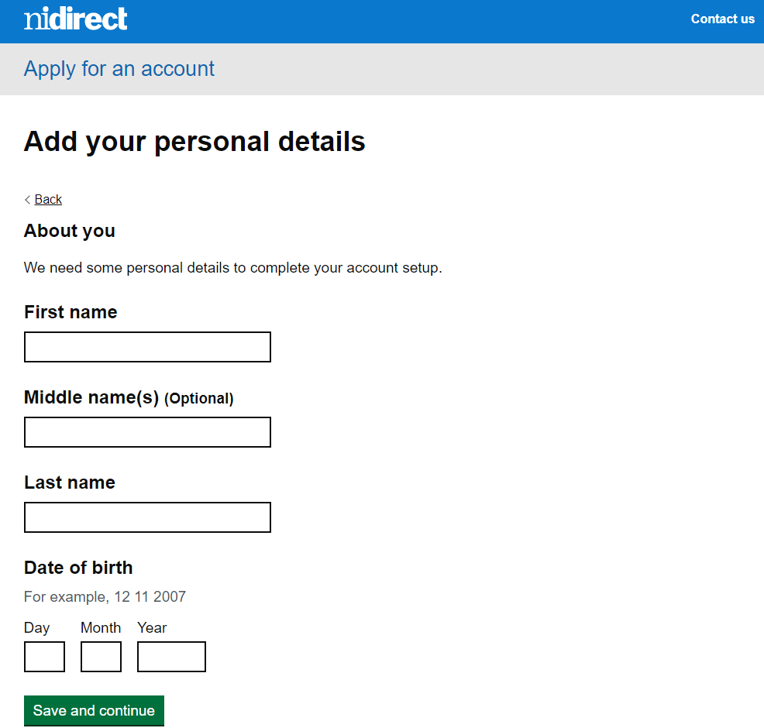
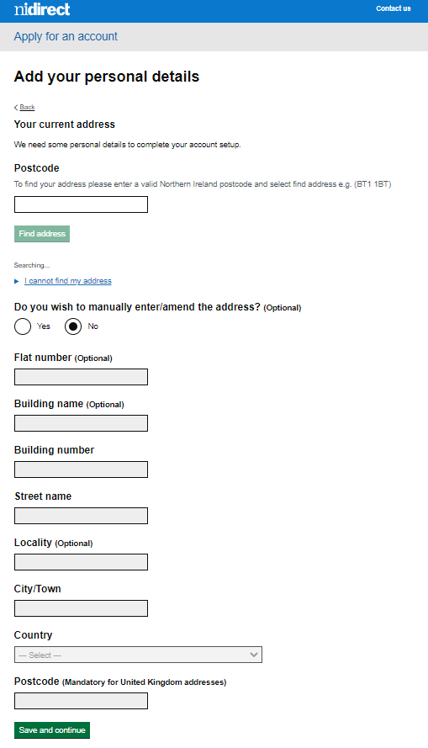
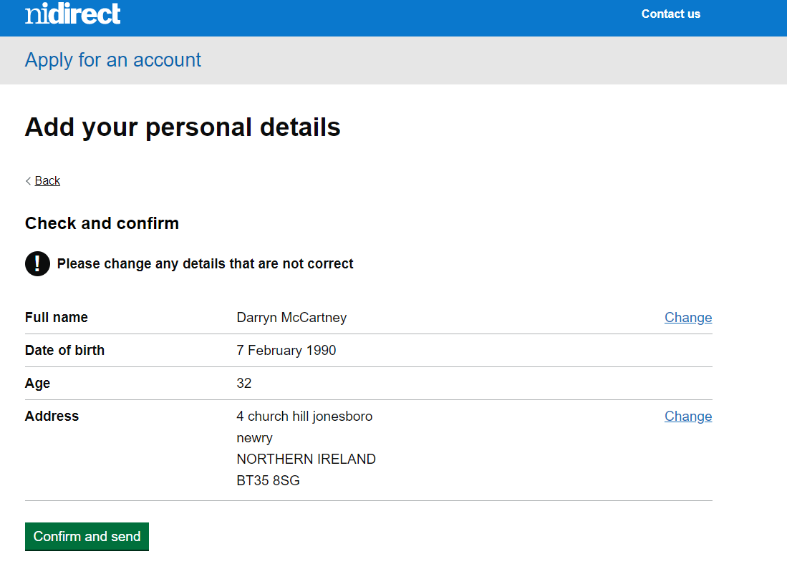
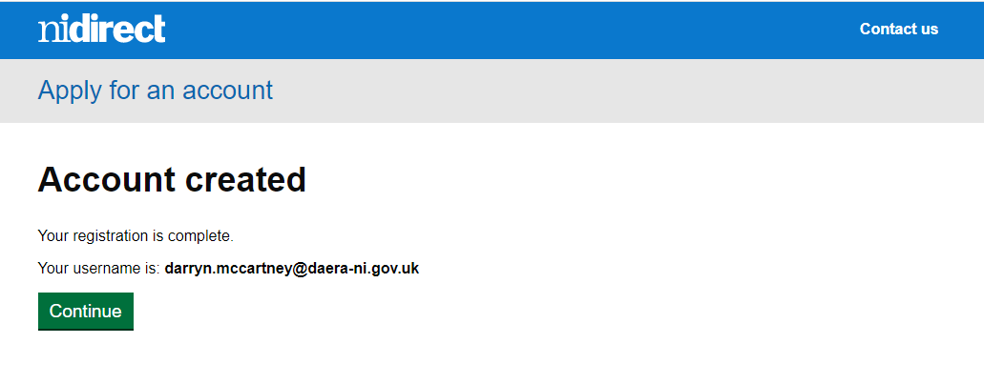
Once this button is hit the user will then be directed back to the RMCGS system and their dashboard.

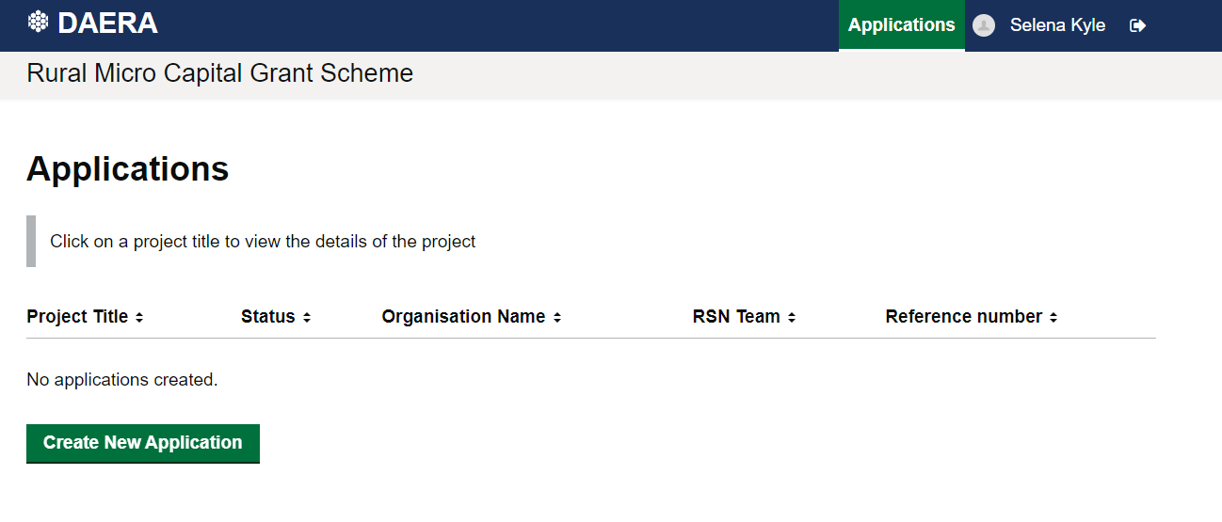

Logging/signing back in once an applicant has applied
DO NOT DIRECT THEM TO ANY OTHER LINK THAN THE FOLLOWING.
https://daera.outsystemsenterprise.com/RMCGS/StartPage
DIRECT THEM TO THE RURAL MICRO CAPITAL GRANT SCHEME URL ABOVE WHICH WILL ALWAYS OPEN THE PAGE BELOW.

Again, they will directed to the following screen, same as before.
But then they will just need to LOG IN/ sign in from this point forward any time they come back into the site.
They can log in and out as many times as they want, but emphasis on logging in / signing in and not registering.
It would also be important to note that Chrome does ask users do they want to save their log in details I would advise they do this. If not, then they will need to remember their log in details they registered with and this is where we have ran into several issues in other grant schemes.
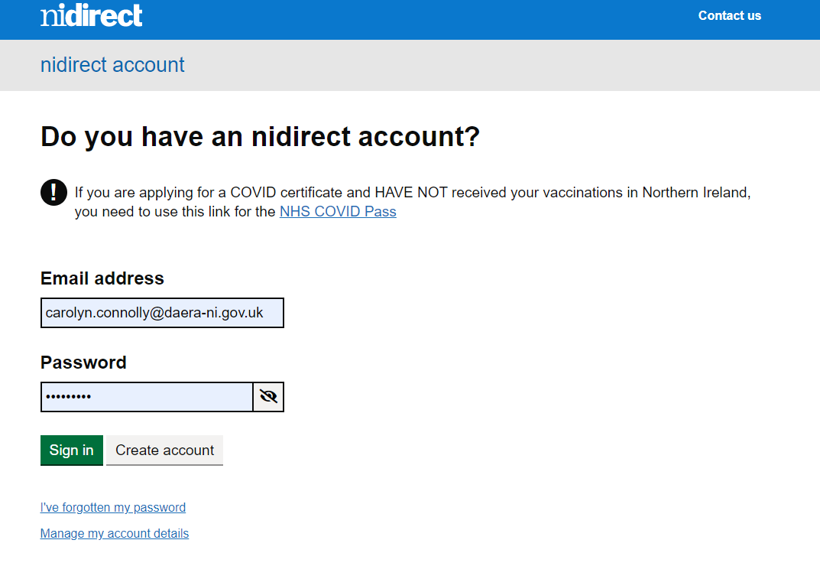
Once they sign in/log in they will always be redirected back to the Rural Micro Capital Grant Scheme dashboard unique to their login details.
Number 1 issue that has arisen, when a user registers, goes away, comes back, they then re-register forgetting their details, they may send emails to the effect of “when I logged back in my application has disappeared” it has not, they have not logged back in, they have re-registered and therefore nothing will appear as the system sees them as a new user. This is one troubleshooting issue you guys will be able to tackle from your end going forward knowing the above information and the differences between first time registration and repeatedly logging in/ signing in.

Users who already have an NI Direct or Government Gateway Accounts
For users who have an account, they will follow the four screens below
RMCGS Log in screen > (IMOS) NI Direct/government gateway screen > Sign In > Dashboard

RMCGS Log in screen

(IMOS) NI Direct/government gateway screen

Sign In

Dashboard

