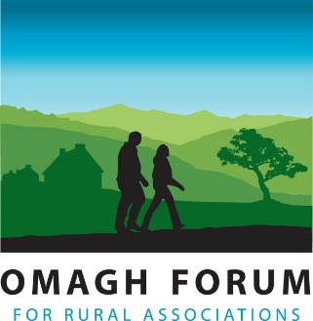

APPLICATION FORM

Application Form to be returned to: maryt.conway@omaghforum.org
Omagh Forum for Rural Associations, Omagh Community House, 2 Drumragh Avenue, Omagh, BT78 1DP

POSITION APPLIED FOR: Omagh Healthy Living Network Co-Ordinator May 2023

SURNAME

FORENAMES

ADDRESS:

POSTCODE:

TELEPHONE NOS: (Daytime) (Home)

EMAIL:

Do you hold any of the following licenses / certificates? Please Tick Box

Full Driving License | No. of Penalty Points (If Any?) | First Aid Certificate  Expiry Date: ___________________
Do you have access to a means of transport that would ensure you can carry out the duties of the post?
Yes No

Are you registered disabled?
Yes No

MEDICAL HISTORY
Give details of any illness, operation or accident resulting in lengthy absence from work.

EDUCATION
Dates | School/College/  University | Subjects | Grade

Any other relevant Qualifications or Training?
Date | Duration | Course Organisers | Subject | Grade

EMPLOYMENY HISTORY
Present / Most Recent Employer
Name & Address | Job Title
 | Date Commenced
 | Date Left (If Applicable)
 | Amount of Notice Required
 | Contact for Reference
 | Present Salary | £ per
Reasons for Leaving / Wishing to Leave?

Brief Description of Duties

EMPLOYMENT HISTORY (Please start with your 2nd most recent employer)
Dates | Name & Address of Employer | Position Held & Brief Description of Duties | Reason for Leaving | Salary

HOBBIES & INTERESTS
What interests do you have? (Include any details of voluntary work etc.)

ACCOMPANYING STATEMENT
Please provide details of relevant experience to the duties of this post outlined in the job description and any further information you think would be useful to your application. Continue on a further sheet if you feel it necessary.

ADDITIONAL
Relevant involvement in Community and Voluntary Work.

Date you would be free to take up the post, if appointed:

___________________________________________________________

REFEREES - Please provide the name and address of two referees (at least one of whom must be your present or past employer). References will only be taken up if you are offered the post and job offer will be subject to satisfactory references being obtained.
Name, Address, Tel No & email | Name, Address, Tel No & email

I certify that all the information I have given is correct. I understand that any false information given may result in any job offer being withdrawn.

Signed: Date:

Your digital signature will be used to prove your understanding and acceptance of this declaration

Please return the completed application form on or before:
12 noon on Thursday 25th May 2023
to maryt.conway@omaghforum.org
Monitoring form to be taken in a sealed envelope to interview (if and when called)
Interviews taking place Monday 5th June 2023

