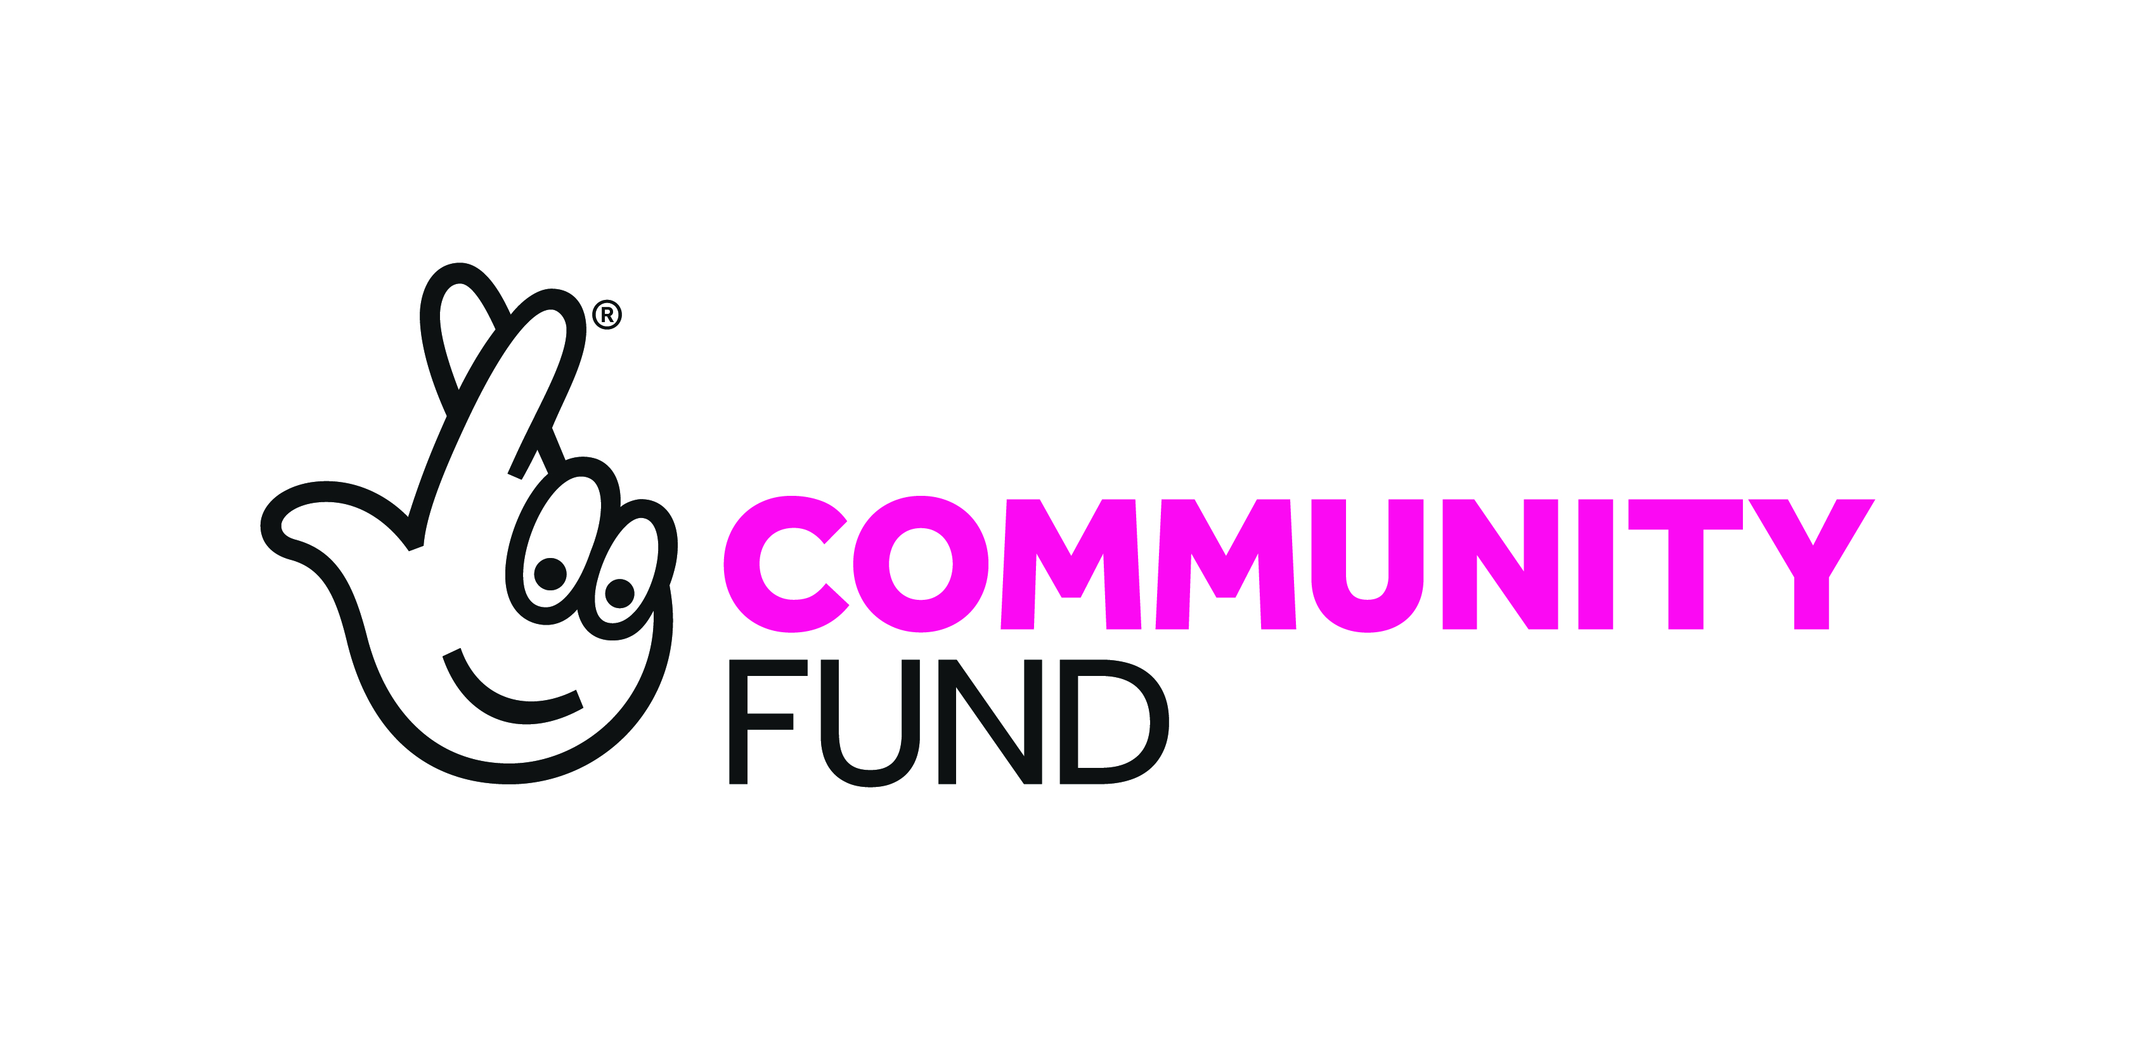

Job Description

JOB TITLE: Omagh Healthy Living Network (HLN) Co-ordinator

RESPONSIBLE TO: Network Manager

Status of Post: Fixed term contract until 30th June 2027, subject to continued funding.

Hours of Duty: 30 hrs Per Week

Evening work and a flexible approach are expected.

Holidays: 25 Days plus 12 Statutory Days with pay plus one additional day for each year of service up to a Maximum of 30 days – pro rata

Time off in lieu: Overtime will be remunerated by Time Off in Lieu to be taken within two months of overtime worked or in accordance with any arrangements made with the Board of Directors.

Salary: (NJC SO1 Starting Pt 23 - £30,151 pro rata pro rata)

Pension: 5.9% contribution of gross salary

Place of work: Across the Omagh District
Primary business: Omagh Forum Office, Omagh Community House,
2 Drumragh Avenue, Omagh, Co. Tyrone, BT78 1DP

Overall Purpose of the Job:
As the Healthy Living Network Co-ordinator you will have lead responsibility to ensure dynamic, supportive and effective health & wellbeing services are developed and delivered across the Omagh area, both rural and urban. The post holder will lead on the strategic development and day to day management of the Healthy Living Network.

This position is funded by National Lottery Community Fund

MAIN RESPONSIBILITIES

Programme Delivery
- Lead the HLN’s strategic development ensuring continued and appropriate provision of health and wellbeing services for the local population.

- Day to day management of the HLN including line management and supervision of staff and volunteers as well as recruitment and selection when appropriate.

- Identify current provision of health promotion activities and develop a database of potential trainers/ facilitators.

- Develop a range of programmes to meet local health promotion needs, taking account of point 3.

- To ensure effective implementation of service level agreements and contracts.

- To assist in identifying and meeting health and wellbeing needs across the Omagh area, both rural and urban.

Planning
- Lead on the planning, implementation and evaluation of future HLN developments ensuring local needs are met and outcomes achieved.

- To apply for funding/tender opportunities securing the current and future sustainability of the HLN.

Partnerships and Stakeholders
- Participate in strategic groups and input into strategic frameworks to ensure issues regarding health inequalities are addressed and to represent the needs of the population of the Omagh district.

- To participate/lead (as appropriate) in the Fermanagh and Omagh Community Plan and the Healthy Living Centre Regional Alliance, including the securing and delivery of services.

- To work closely with Western HLCA’s to build strategic linkages.

- To provide regular communication to participating GP Practices and other medical professionals.

- To participate in the regional management group of Social Prescribers.

- To create and maintain full engagement of key stakeholders at all stages of the project.

- Encourage and support inter-agency work and an effective co-ordinated response to the needs of local people within the project’s framework.

Management Systems and Monitoring
- Implement robust performance management systems ensuring the HLN delivers its strategic and operational aims and objectives.

- Ensure the project is managed robustly in terms of budgets, finance, social impact, procedures, legal requirements and quality standards.

- Produce accurate and timely reports for the management team, Omagh Forum board and funders.

- To process and update monitoring information for clients including the use of monitoring software.

- To ensure that end-of-programme evaluations and reports are produced as required for internal and external purposes where appropriate.

- Provide guidance and support on issues relating to safeguarding.

- To ensure compliance with all Omagh Forum polices in particular reference to the health and safety, equal opportunities and communication policies.

- Continuous development of skills through training for both self and staff.

Awareness and Communication
- Raise awareness of local health inequalities by networking with the community, voluntary, statutory and private sectors.

- To publicise and promote the HLN project with stakeholders.

The concept of team working means that a flexible approach to work areas is required from the postholder. The work areas identified above are not exhaustive and only represent current principal tasks. The post holder may therefore be required to carry out other duties as determined by Omagh Forum from time to time.

P E R S O N N E L S P E C I F I C A T I O N

The personnel specification shows essential skills, abilities, knowledge and/or qualifications required to be able to carry out the duties of this post. Please therefore address, in completing the application form, each criterion listed in the specification, drawing upon all of your experience, whether at work or on a voluntary basis.

Ref | Area | Essential (E) | Desirable (D)
Education / Experience
E1 | Third level qualification and / or recognised professional qualification in a relevant field*  +  A proven track record of 3 years full time experience of working in the field of health and / or community development at a senior level**
E2 | Or  A proven track record of five years’ full-time experience working within the field of health and / or community development at a senior level**
D1 | Relevant management qualification
Experience and Knowledge
E3 | Evidence of two years’ experience of project development and management
E4 | Evidence of two years direct line management of staff
E5 | Proven experience in the preparation and completion of funding applications and tenders
E6 | Proven knowledge of the current health and wellbeing issues impacting individuals, families and communities across N. Ireland
E7 | Proven knowledge of ICT with proficiency in the use of Microsoft Office packages
Skills and Abilities
E8 | Proven ability in establishing and maintaining collaborative cross sectoral partnerships gaining respect and credibility both internally and externally with partners
E9 | Proven self-management skills and the ability to work on own initiative
E10 | Proven ability to implement and maintain monitoring and evaluation processes
E11 | Proven financial management ability
E12 | Proven high level of written and oral communication skills including report writing, presentation skills and the ability to engage key stakeholders.
D2 | Full driving licence and access to a car***
Values & Behaviours
E13 | Ability to work flexibly to meet the requirements of the post
E14 | Commitment to the principles of community led health and wellbeing

*Relevant qualification to include; community development, social work, youth work, psychology, sociology or equivalent

**Senior Level is defined as minimum experience at NHS Band 6 or NJC SO1

*** This criterion will be waived in the case of a suitable applicant who has a disability which prohibits them from driving but who is able to organise suitable alternative arrangements in order to meet the requirements of the post in full.

