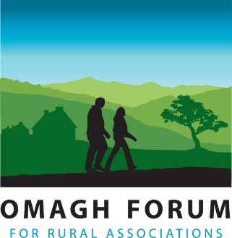

APPLICATION FORM

Application Form to be returned to: maryt.conway@omaghforum.org
Omagh Forum for Rural Associations, Omagh Community House, 2 Drumragh Avenue, Omagh, BT78 1DP

POSITION: Household Enabler

SURNAME

FORENAMES

ADDRESS:

POSTCODE:

TELEPHONE NOS: (Daytime) (Home)

EMAIL:

Driving License and Transport - Please Tick Box

Do you have a current valid driving license? Yes No

Do you have access to a means of transport that would ensure you can carry out the duties of the post?
Yes No

How did you find out about the job?
Omagh Forum website Social Media Newspaper CommunityNI

Omagh Forum Ebulletin Word of mouth Other, please state:

Disability Discrimination Act 1995
Section 1 of this act defines a disabled person as a person with “physical or mental impairment which has a substantial and long-term effect on his/her ability to carry out normal day to day activities”
Using this definition, would you consider yourself to be disabled? Yes No

If yes, do you require any special arrangements to be made to assist you if called for interview?
Please provide details

EDUCATION
Dates | School/College/  University | Subjects | Grade

Any other relevant Qualifications or Training?
Date | Duration | Course Organisers | Subject | Grade

Are you available to attend training as required for the job? Yes No

Are you available to carry out household visits between September 2026 and September 2027
Yes No

EMPLOYMENT HISTORY
Present / Most Recent Employer
Name & Address | Job Title
Name & Address | Date Commenced
Name & Address | Date Left (If Applicable)
Name & Address | Amount of Notice Required
Name & Address | Contact for Reference
Name & Address | Present Salary | £ per
Reasons for Leaving / Wishing to Leave?

Brief Description of Duties

EMPLOYMENT HISTORY (Please start with your 2nd most recent employer)
Dates | Name & Address of Employer | Position Held & Brief Description of Duties | Reason for Leaving | Salary

HOBBIES & INTERESTS
What interests do you have? (Include any details of community or voluntary work etc.)

ACCOMPANYING STATEMENT
Please provide details of relevant experience to the duties of this post outlined in the job description and any further information you think would be useful to your application. Continue on a further sheet if you feel it necessary.

Date you would be free to take up the post, if appointed:

___________________________________________________________

Are you willing to undergo an Access NI Check to obtain a Disclosure certificate issued by Access NI? Yes  No

REFEREES - Please provide the name and address of two referees (at least one of whom must be your present or past employer). They need to be able to comment on your ability to undertake the duties of this post. References will only be taken up if you are offered the post and job offer will be subject to satisfactory references being obtained.
Name, Address, Tel No & email | Name, Address, Tel No & email

I certify that all the information I have given is correct. I understand that any false information given may result in any job offer being withdrawn or my employment terminated.

Signed: Date:

Your digital signature will be used to prove your understanding and acceptance of this declaration

Please return the completed application form on or before:
12 noon on Thursday 30th July 2026
to maryt.conway@omaghforum.org

Monitoring form to be taken in a sealed envelope to interview (if and when called)

Interviews taking place week commencing 10th August 2026

